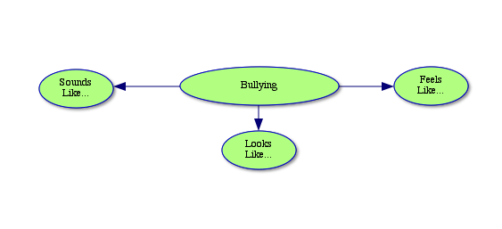
Brainstorm on the web below, branching off from the different bubbles.

